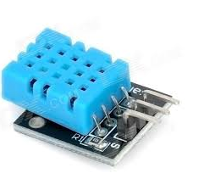
This project uses DHT11 sensor module to get environment temperature and humidity and show them in serial monitor window.
Step 1: connect DHT11 sensor to Arduino as per following circuit graph.
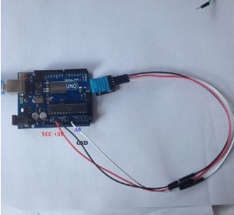
Step 2: Download sketch code and load it into Arduino IDE.

